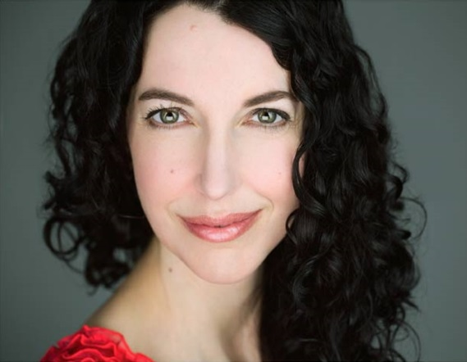
Amanda Hennessey, MFA
Public Speaking and Acting Coach
Founder of Boston Public Speaking

Amanda has coached clients from a variety of industries, including scientists, writers, activists, lawyers, businesspeople, librarians, entrepreneurs, artists, designers and even a top dog trainer.

She teaches acting at Boston Acting Classes, which she co-founded with her husband, and at the Film/TV Department at Boston University's College of Communication. She has also taught at the New York Film Academy and The Huntington Theatre Company. Amanda received her MFA at the Actors Studio Drama School at the New School.

Amanda has acted in films, commercials and onstage. In the upcoming indie thriller Off Season, she plays a farmer's wife with a few too many skeletons in her closet.

She also founded Inhabit You Coaching and Workshops. Inhabit You is an innovative and playful way to approach changing habits. www.inhabityou.com

Amanda has many creative adventures with her wonderful husband, Art. She also collects a lot of hats and greek yogurt is her constant companion.

Peggy Lynn Romero, MS, MBA
A financial primary care provider
The Bulfinch Group: Uncommon Thinking, Exceptional Outcomes

As a financial primary care provider, Peggy’s role is to integrate all elements of a client’s financial world into a unified strategy for financial wellness, success and fulfillment. She accomplishes this goal by demystifying complex ideas and combining in-depth discovery (a financial X-ray), uncommon thinking and unbiased, transparent analysis. As with other primary care providers, Peggy introduces specialists into the process when indicated to fully support a client’s personal needs and goals. A strategic path forward is formulated for each client, aligned with their hopes and dreams to give them clarity and confidence for the future.

Prior to joining Bulfinch, Peggy was active in multiple biotechnology companies from start-up to IPOs and acquisitions by pharmaceutical companies at “the bench” (as a scientist) and in operations management. As a result, she understand the analytical process, entrepreneurial spirit and the drive to create lasting value at both the individual and business levels. She brings this positive energy and commitment to every client engagement.

Peggy lives in Arlington, MA with her husband of 32 years. She loves her family – both the humans and the furry animals- learning, biology, languages, music, fitness and medical missions, where she has served as a translator for over 15 years.

Her favorite clients are smart, curious, open-minded people who will ask questions. Are you due for a check-up? She can provide the comprehensive financial care you want– as your financial primary care provider. Give her call!

